Calling all Bridge Learners and Improvers



Come and play at our Free No Fears Duplicate



Bridge evening on Wednesday 14th August.

Please arrive at 7.00pm for a 7.15pm start.

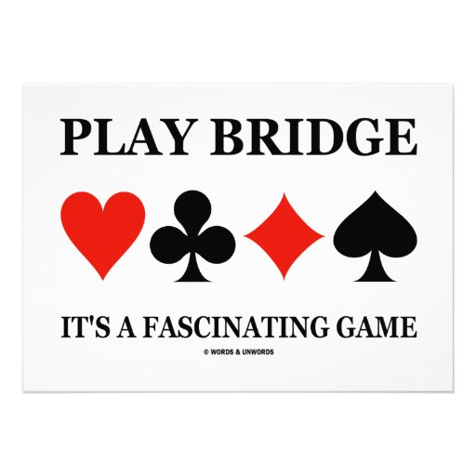



**Probably the friendliest club around!**

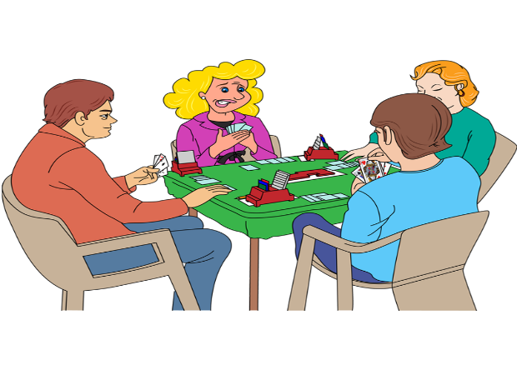



At Bordon Bridge Club

Whitehill Village Hall, 6 Sutton Field, Bordon,

GU35 9BW

Join us for a welcoming and friendly relaxed evening

For more information contact Loraine Rae

E: [ianjamesrae@gmail.com](mailto:ianjamesrae@gmail.com) T: 01252 715324

**Find out more about Bordon Bridge Club** www.bridgewebs.com/bordon