We looked at what to think about when you are making a plan as declarer in No Trumps.
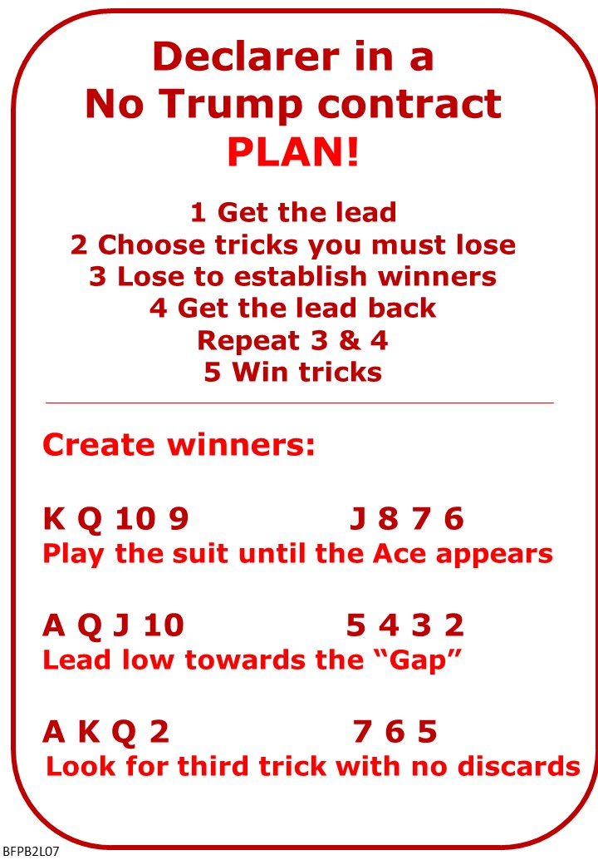
Please find attached:
Lesson 6 Homework with Answers
Lesson 7 Notes - SUMMARY Bid the Story
Lesson 7 Notes - Playing in No Trumps
Lesson 7 Quiz

On No Fear Bridge:
Menu across the TOP: Practice Hands and Quizzes
Then: Declarer Hands
Level 1: Beginners
Play: Setting Up a Long Suit in No Trumps

Bernard Magee
Bernard Magee has the largest bridge teaching and coaching website. Most of it is restricted to members paying a subscription.
https://bernardmageebridge.com/

BUT there is a free novice seminar every Monday morning and they are all available for free afterwards.
Here's link to one on YouTube, there's a bit of advertising first, but keep going...
https://www.youtube.com/watch?v=05wmr2cVXNE

