​Last lesson we talked about the Losing Trick Count and using it to find game contracts that depend on distribution rather than HCP measured power.

Most of the time, declarer’s first priority is to clear trumps. However, sometimes, and often when the game is dependent on distribution, there is a reason to DELAY clearing trumps.

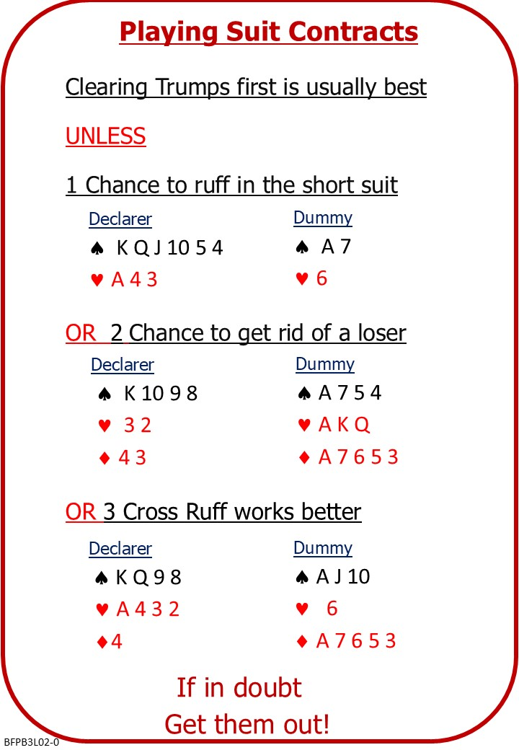

We also looked at three possible strategies where trump clearance is delayed: ruffing in the short trump suit; discarding a side suit loser on a side suit winner; creating a side suit shortage in each hand and cross ruffing.

Attached Documents:
- B3 L01 QUIZ ANSWERS Losing Trick Count
- B3 L02 NOTES Playing Suit Contracts
- B3 L02 QUIZ Playing Suit Contracts

No Fear Bridge
You might like to practice on No Fear Bridge
- On the Home Page, From the horizontal menu across the top, select "Practice Hands and Quizzes"
- Then “Declarer Hands”
- From the list, under Level - 1
  - Drawing Trumps
- From the list, under Level – 2 Improvers
  - Ruffing and Discarding Losers

Invite to Next Lesson
If online send link/joining instructions
If face to face remind venue, day and start time.

