Last lesson we talked about the importance of clearing trumps. We looked at the probable distribution of opponents’ trumps, and using that in your PLAN. Most of the time, declarer’s first priority is to clear trumps.

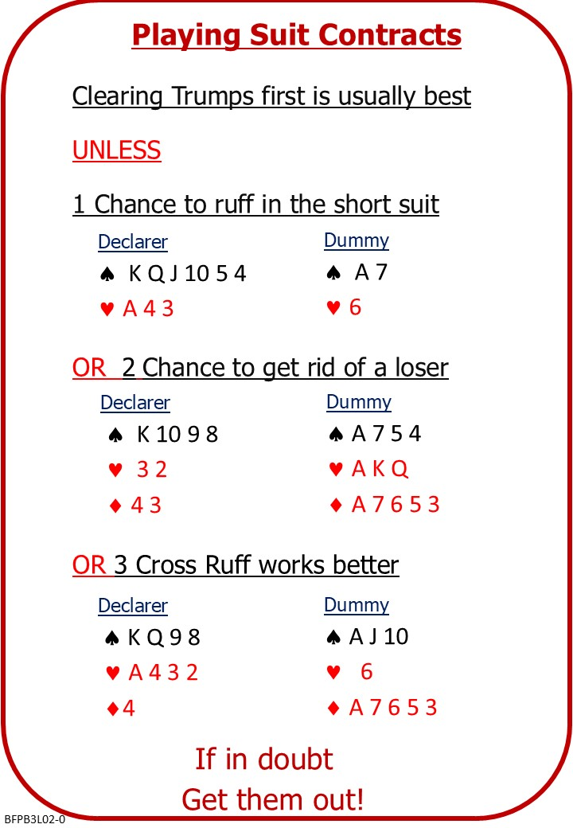

We also looked at three possible strategies where trump clearance is delayed: ruffing in the short trump suit; discarding a side suit loser on a side suit winner; creating a side suit shortage in each hand and cross ruffing.

Attached Documents:
- B3 L02 Playing Suit Contracts NOTES

No Fear Bridge
You might like to practice on No Fear Bridge
- On the Home Page, From the horizontal menu across the top, select "Practice Activities"
- From the list, under “Declarer Practice”
  - Drawing Trumps
- From the list, under Level – 2 Improvers
  - Ruffing and Discarding Losers

Invite to Next Lesson
If online send link/joining instructions
If face to face remind venue, day and start time.

