We talked about bidding very strong balanced hands. These hands would have 19 or more HCPs.

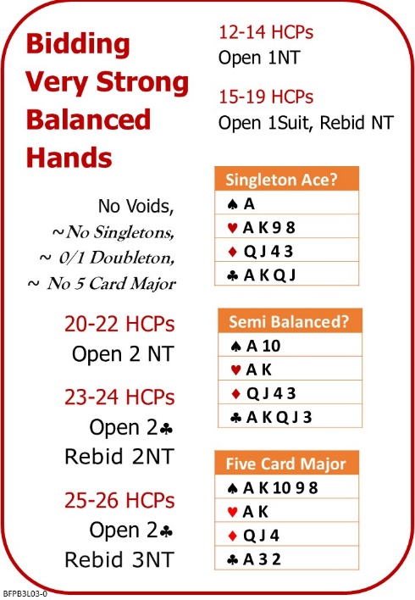

Attached Documents:
- BFP L02 Playing Suit Contracts Quiz Answers
- BFP L03 Very Strong Balanced Hands NOTES
- BFP L03 Very Strong Balanced Hands Quiz

No Fear Bridge
You might like to practice on No Fear Bridge
- On the Home Page, From the horizontal menu on the left, select "Topic Index"
  - From the list, under Bidding Topics Alphabetically
    - Opening 2NT and Simple Responses
    - Two Club Opening (with 2D negative response)

Invite to Next Lesson
If online send link/joining instructions
If face to face remind venue, day and start time.

