In our lesson we looked at planning declarer play.
Most of the time the best result comes from clearing trumps at the earliest opportunity.
Sometimes, there are good reasons for delaying trump clearance.
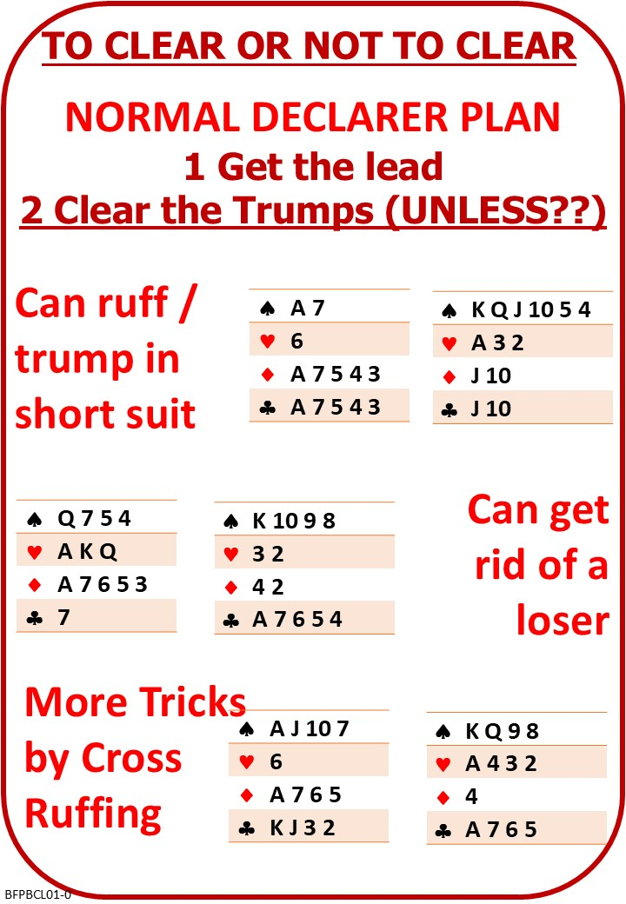

Please find attached:
BFP BC L01 NOTES To Clear or Not to Clear

On No Fear Bridge:
Middle Button: “Practice Hands and Quizzes”
“Level 1 - Beginners”
Discarding Losers

Also: Switch to Planning Practice menu
Lots to try

