In our lesson we looked at planning declarer play particularly unblocking and managing entries.
This is an aspect of planning your play BEFORE you call for the first card from dummy.
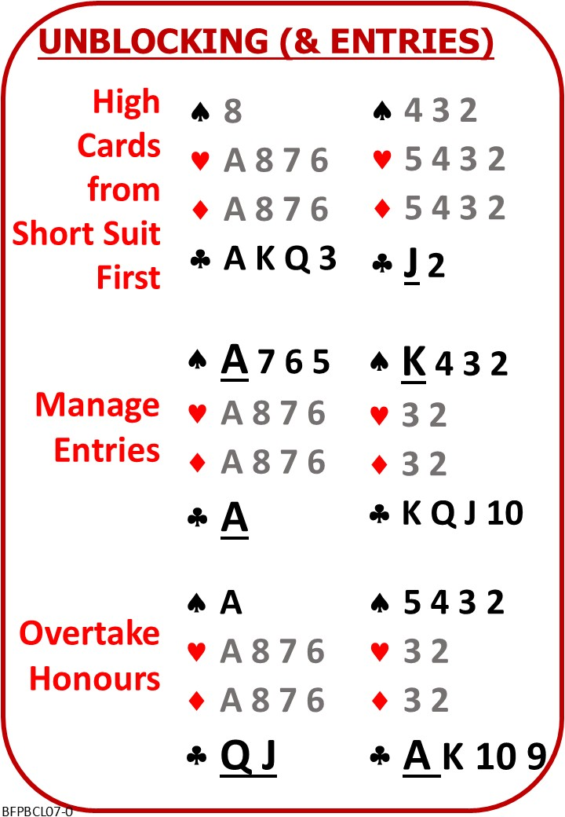

Please find attached:
BFP BP L0& NOTES Unblocking

On No Fear Bridge:
Left Column Menu: “Topic Index”
“Declarer Play Topics Alphabetically”
“Unblocking”
Play as many as you like

Next Lesson

