In our lesson we looked at using discards to signal to partner our preference, or not, for a given suit.
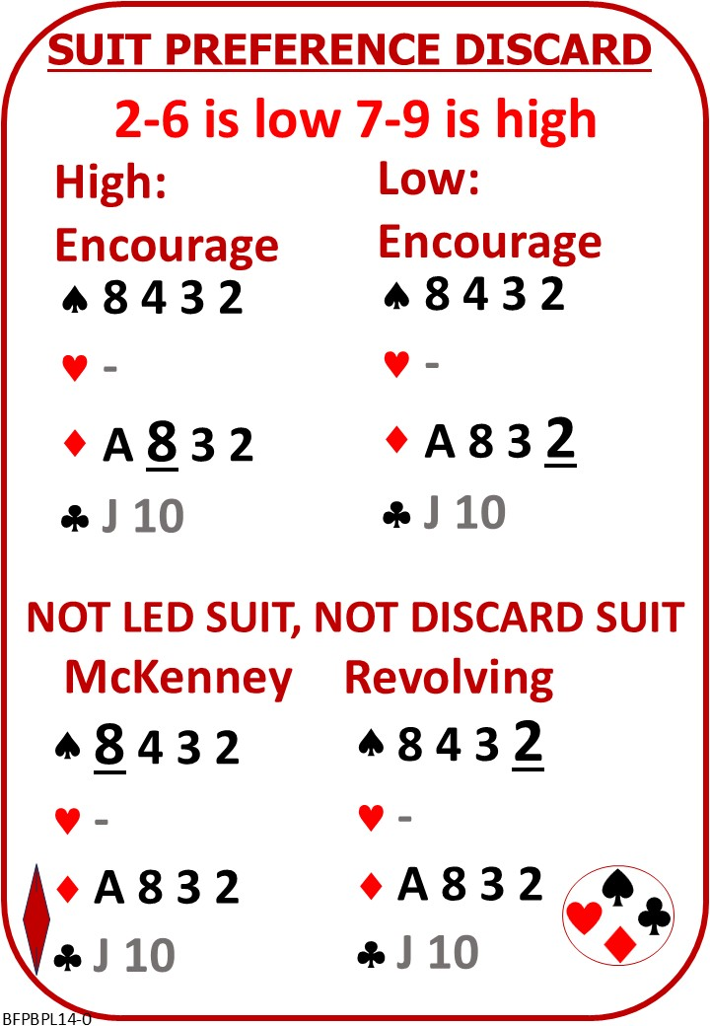

Please find attached:
BFP BP L14 NOTES Suit Preference Discards

On No Fear Bridge:
Left Column Menu: “Topic Index”
“Defence Topics Alphabetically”
“Suit Preference Signals”
The tutorial and the hands is based on HELD
Do watch the tutorial and play as many hands as you like
You might want to consider for yourself how another discard system would have worked.

