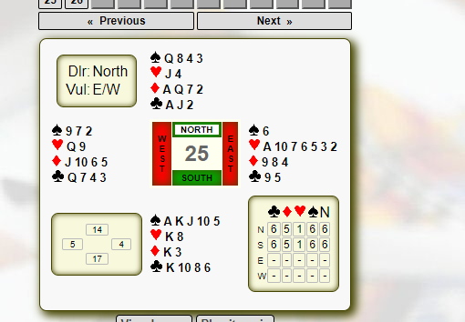
essex leagues
2025/2026
A Great Opportunity
The Essex Leagues offer a team-based bridge competition running from October to May, where matches of 24 boards are typically played in players' agreed venues, including online if all players agree. There will be approximately 6 games played over the course of the 8 month period.

This is open to ALL players regardless of your NGS – ALL players are welcome!

Interested? Just a little bit……just enough to want to know a bit more

Well there’s good news for you
Email me – Gemma Fewster, and I’ll send more info.
Sec.essexleagues@gmail.com

It’s enjoyable and it will help improve your bridge

Entry Fee of £20 per team

