OLIVER COWAN BRIDGE CLUB presents
Charity Handicap Pairs
Saturday 3rd May @ 1pm-5pm on BBO
(16 x 2 BOARD ROUNDS WITH A 15 MINUTE BREAK)

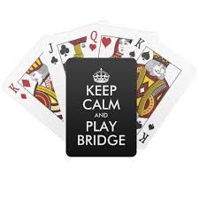
Entry Fee only $10 BBO per player and the event is suitable for all players. All proceeds raised after platform, UMS and TD charges will be going to the North West Air Ambulance.

There is no need to book in advance for this game – just turn up and register on BBO on the day from 11am and the game will be under “Oliver Cowan Charity Pairs”. If you want to play but do not use dollars then please send £8 per player by BACS to: sort code 20-48-95 account 43186903 account name Oliver Cowan Bridge Ltd AND send an email to ocbridgecomps@gmail.com with your BBO name so dollars can be added to your BBO account.

If you have any questions, please call 07946 393033 any time or send an email to ocbridgecomps@gmail.com. Full details of the fundraiser we are supporting can be found at the following link and you can also use this link if you are unable to play but want to support the charity! Steph's justgiving page

DATA PROTECTION - Members providing the personal information on this form should note that this will be collected, stored, used and protected in line with the Oliver Cowan Bridge Club GDPR Privacy Notice as published on the Oliver Cowan Bridge Club website http://www.bridgewebs.com/olivercowan

