EBU Score with BridgeMates

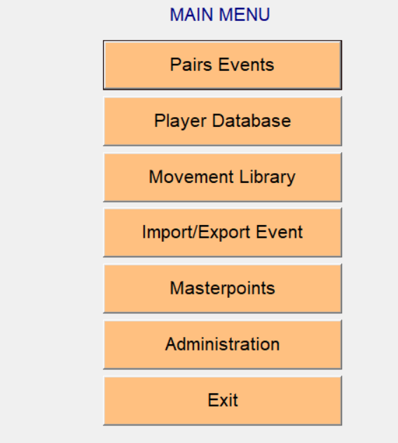

Select **Pairs Event**

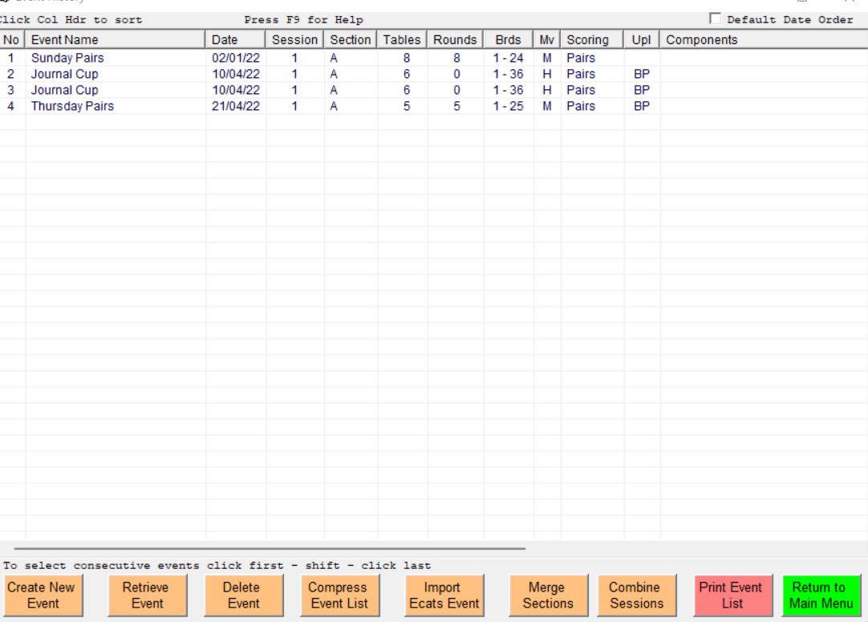

Select **Create New Event**

Should be auto filled out, just check looks OK.

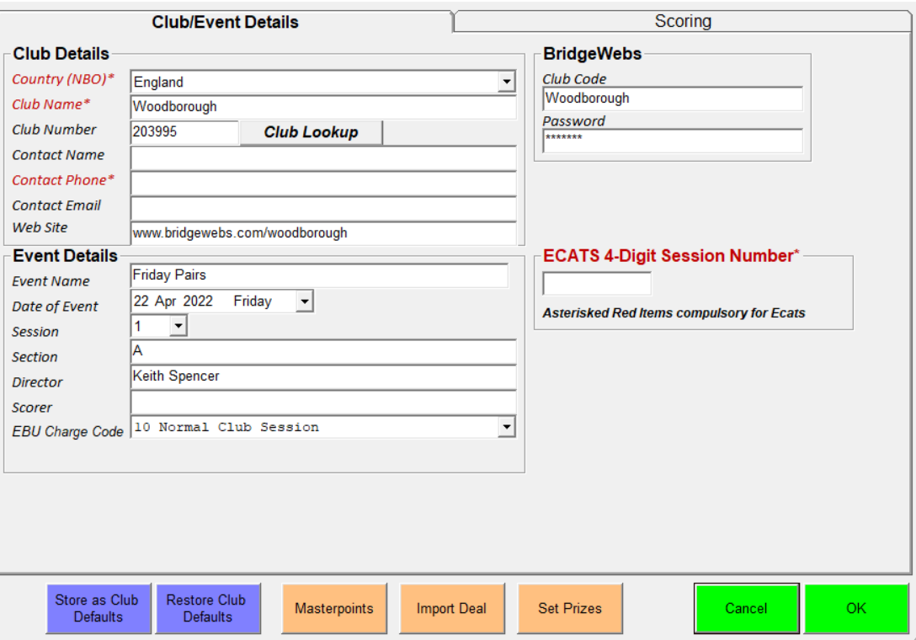

**OK**

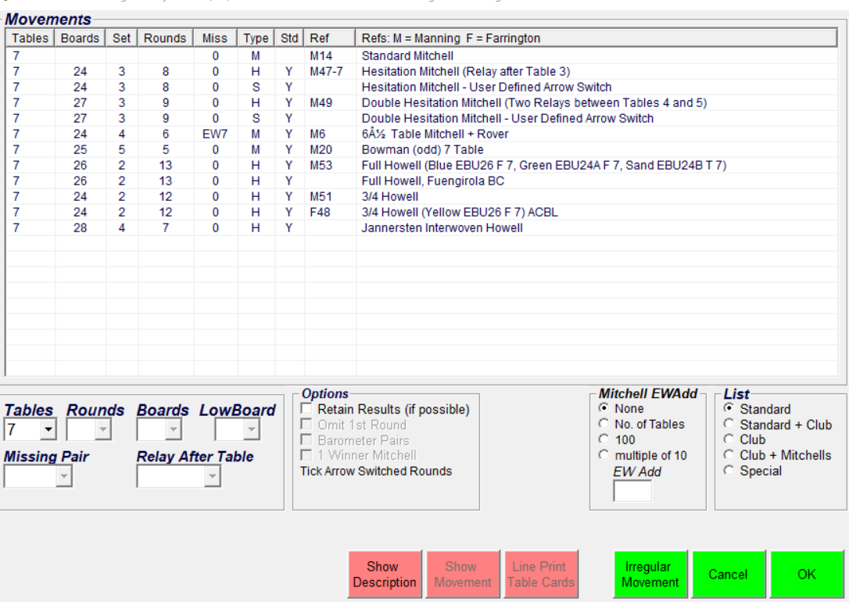

Select number of Tables

EBU Score will then give you a selection of Movements.

Highlight required movement

This will fill in Rounds and Number of Boards. Amend as required.

Select **OK**

Confirm Details **Yes**

This takes you back to Menu.

Select **Bridgemate Scoring**

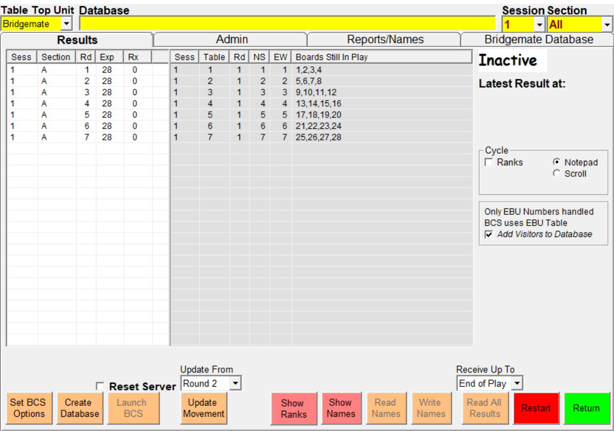

Set BCS Options: this allows you to change settings on the Bridgemates.

Select Create Database

Select Launch BCS

Advantage of EBUScore is it is much easier to amend movement.

Return

Select Movement

Amend Movement

Bridgemate Scoring

Select **Update Movement**. Just make sure you amend from the correct Round.

Results

Select **Reports** from Menu

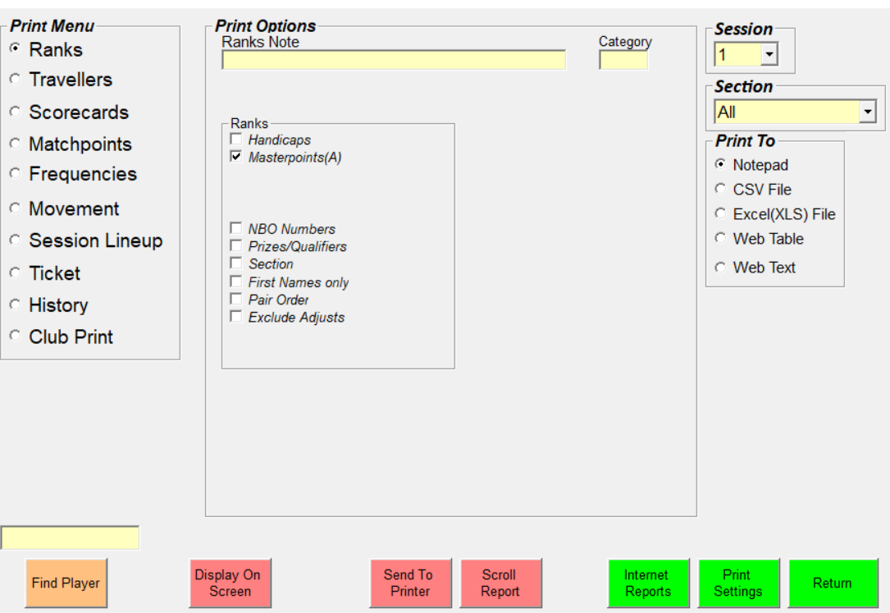

Select **Display on Screen**. This shows results.

To Publish Results, select Internet Reports

This page should be prefilled.

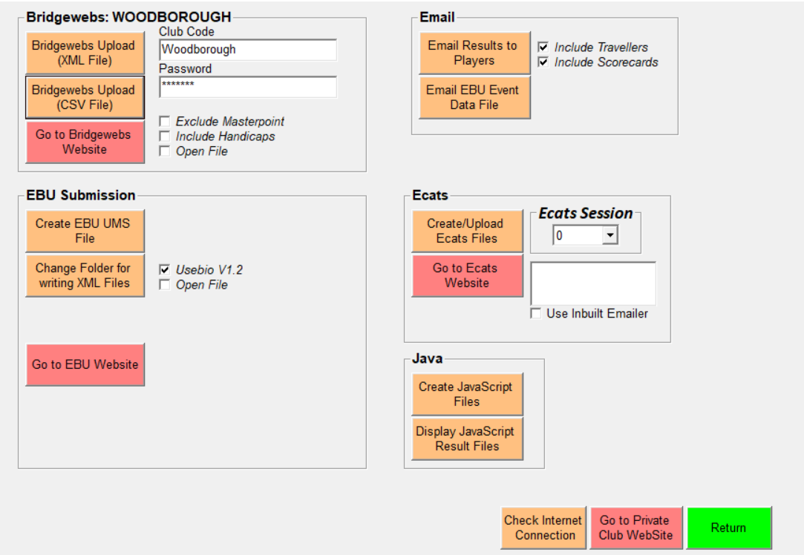

Select **Bridgewebs Upload (XML File)**

All should be OK?

To manually enter missing Names,

From Menu select Player Names

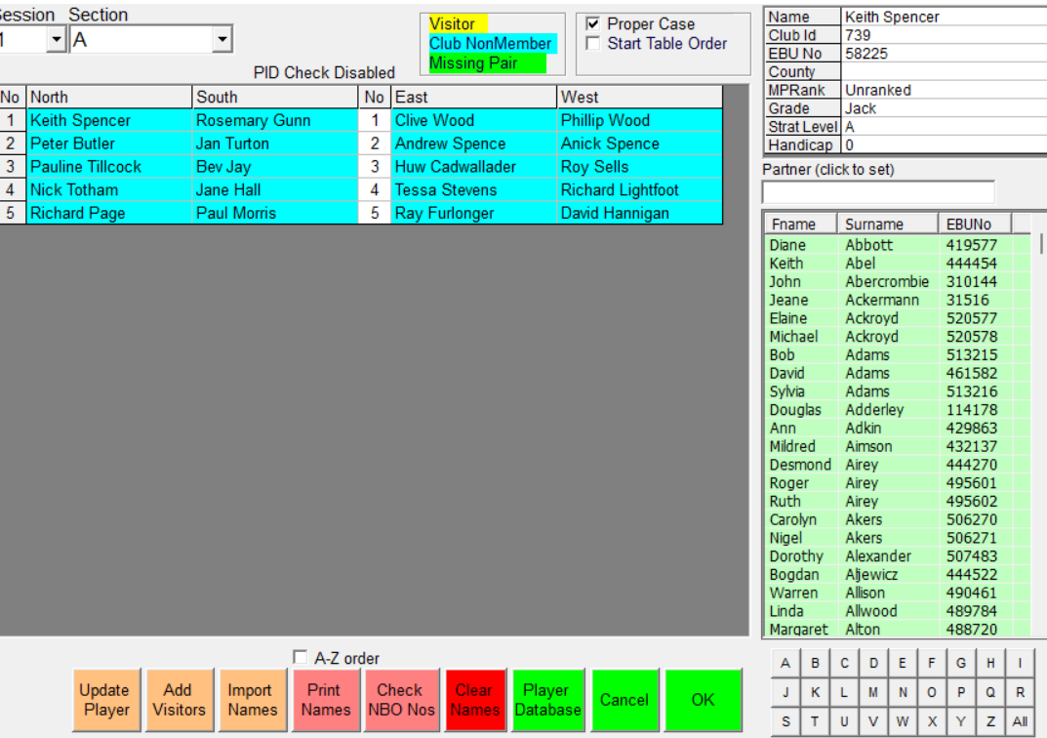

Just be careful to make sure you are entering Names into correct Field!!