OPENING LEADS
Card led is highlighted in bold
v Suit contracts | A K | A K x | K Q 10 | K Q x | K J 10 | K 10 9 | Q J 10
v Suit contracts | Q J x | J 10 x | 10 x x | 10 9 x | 9 8 7 x | 10 x x x | H x x
v Suit contracts | H x x x | H x x x x | H x x x x x | x x | x x x | x x x x
v NT contracts | A K x (x) | A J 10 x | K (Q) 10 | K Q x | K J 10 | K 10 9 | Q J 10
v NT contracts | Q J x | J 10 x | 10 x x | 10 9 x | 9 8 7 x | 10 x x x | H x x
v NT contracts | H x x x | H x x x x | H x x x x x | x x | x x x | x x x x
Other agreements in leading, e.g. high level contracts, partnership suits:-
Against a suit contract:

Against No Trumps

Carding methods
 | Primary method v. suit contracts | Primary method v. NT contracts
On Partner’s lead
On Declarer’s lead
When discarding
Other carding agreements, incl secondary methods (state when applicable) and exceptions to above

SUPPLEMENTARY DETAILS (continued)
Note 4: Defence to 1N
Type out your defence or write “Natural”
Note 5: Cue Bid
Type out your method or “N/A”

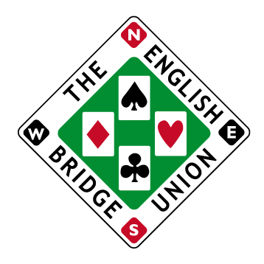 | Name |  | EBU No.
 | Partner |  | EBU No.

GENERAL DESCRIPTION OF bidding methods

1nt openings and responses
Strength
Shape constraints |  |  |  |  | Tic-k if may have singleton 
Responses |  | 2♣
2♦ |  |  |  |  | 2♥
2♠ |  |  |  |  | 2NT
Others
Action after opponents double
Action after other interference

two-level openings and responses
 | Meaning | Responses | Notes
2♣ |  |  | 2
2♦ |  |  | 2
2♥ |  |  | 1
2♠ |  |  | 1
2NT |  |  | 2

other aspects of system which opponents should note
(Please include details of any agreements involving bidding on significantly less than traditional values).

OTHER OPENING BIDS
 | HCP | see note* | Min length | CONVENTIONAL  MEANING | SPECIAL RESPONSES | Notes
1♣ | 11+ |  | 4 | Natural Suit
1♦ | 11+ |  | 4 | Natural Suit
1♥ | 11+ |  | 4 | Natural Suit
1♠ | 11+ |  | 4 | Natural Suit
3 bids | 5-10 |  | 7 | Pre-emptive | Pass unless holding 3 tricks or 15+HCP
4 bids | <13 |  | 8 | Pre-emptive | Pass unless very weak

DEFENSIVE METHODS AFTER OPPONENTS OPEN
NATURAL ONE OF A SUIT |  | conventional meaning | special responses | Notes
Simple overcall
Jump overcall
Cue bid |  |  |  | 5
1NT | Direct:  Protective:
2NT | Direct:  Protective: |  |  | 5
OPPONENTS OPEN WITH |  | DEFENSIVE METHODS | special responses | Notes
Strong 1♣
Short 1♣/1♦
Weak 1NT |  |  |  | 4
Strong 1NT |  |  |  | 4
Weak 2
Weak 3
4 bids
Multi 2♦

SLAM CONVENTIONS
Name | Meaning of Responses | Action over interference

COMPETITIVE AUCTIONS
Agreements after opening of one of a suit and overcall by opponents
Level to which negative doubles apply |  |  | Negative doubles apply up to and including
Special meaning of bids
Exceptions / other agreements
Agreements after opponents double for takeout
Redouble: |  | New suit: |  | Jump in new suit:
Jump raise: |  | 2NT: |  | Other:
Other agreements concerning doubles and redoubles

conventions

SUPPLEMENTARY DETAILS
(Please cross-reference where appropriate to the relevant part of card, and continue on back if needed).
Note 1:

Note 2:
Note 3

