**Trafford Bridge Club**

**Suite 5 Cadman House Wharf Road Sale M33 2AF**

**www.traffordbridgeclub.org.uk**

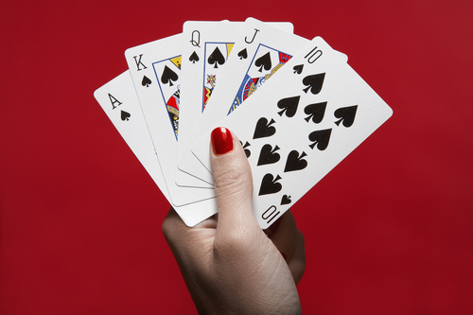

**Bridge for Beginners 2025**

**Lessons start Thursday 25th September 2025**

**7.30 pm – 9.30 pm**

Just **£75** for each module of 10+ lessons + **£20** for the textbook.

Numbers are limited to 32 so please pay a deposit of £15 **\*** to reserve a place on the course

(**\*** The reservation fee is fully refundable if you decide not to continue after the first lesson)

|  |  |
| --- | --- |
| **NAME** |  |
| CONTACT TELEPHONE |  |
| EMAIL ADDRESS |  |
| ADDRESS & POSTCODE |  |
|  |
|  |
|  |

Full details of how to pay by PayPal, card or bank transfer are shown on our website

Please email the completed form to:

Seema

mobile 07808 880627

email seema17@me.com

***PROVISIONAL TIMETABLE OVERLEAF***

**Trafford Bridge Club**

**Beginners’ Course Timetable**

( Provisional )

|  |  |  |  |
| --- | --- | --- | --- |
| **Session 1** | **2023** | ***Topic*** | ***Lesson Title*** |
| Lesson 1 | 28th September | *Getting Started* | Introduction and Minibridge |
| Lesson 2 | 5th October |  | Playing with trumps |
| Lesson 3 | 12**th** October |  | Declarer play |
| Lesson 4 | 19**th** October |  | Defence play |
| Lesson 5 | 26th October |  | *Recap & Play* |
| Lesson 6 | 2nd November | *Bidding* | Auction, 1NT & responses |
| Lesson 7 | 9th November |  | 1NT responses with an unbalanced hand |
| Lesson 8 | 16th November |  | *Recap & Play* |
| Lesson 9 | 23rd November | *Opening 1 of a suit* | One-level suit openings |
| Lesson 10 | 30th November |  | New suit responses |
| Lesson 11 | 7th December |  | Opener’s rebid with strong hand |
| Lesson 12 | 14th December |  | Getting into No Trumps |

|  |  |  |  |
| --- | --- | --- | --- |
| **Session 2** | **2024** |  | **Topic** |
|  | 21st December |  | Holiday |
|  | 28th December |  | Holiday |
|  | 4th January |  | Holiday |
| Lesson 13 | 11th January |  | *Competition* |
| Lesson 14 | 18th January | *Declarer Play* | Declarer play techniques |
| Lesson 15 | 25th January |  | Declarer play in no trumps |
| Lesson 16 | 1st January |  | Declarer play in a trump contract |
| Lesson 17 | 8th February | *Defence* | Opening lead |
|  | 15th February |  | *Recap & Play* |
| Lesson 18 | 22nd February |  | Defender’s play of the cards |
| Lesson 19 | 29th February | *Bidding Competition* | Suit overcalls & responses |
| Lesson 20 | 7th March |  | Simple takeout doubles |
| Lesson 21 | 14th March |  | 1NT overcall & responses |
| Lesson 22 | 21st March |  | Weak jump overcalls |

|  |  |  |  |
| --- | --- | --- | --- |
| **Session 3** | **2024** |  | **Topic** |
|  | 28th March |  | Holiday |
|  | 4th April |  | Holiday |
|  | 11th April |  | Holiday |
| Lesson 23 | 18th April | *Convention* | Stayman convention |
| Lesson 24 | 25th April | *Strong openers* | Opening 2NT & responses |
| Lesson 25 | 2nd May | *Convention* | Opening 2C & responses |
| Lesson 26 | 9th May | *Weak openers* | Weak Twos in three suits |
| Lesson 27 | 16th May |  | Opening at the 3 & 4 level & responses |
| Lesson 28 | 23rd May |  | Defending against a pre-emptive bid |
|  | 30th May |  | *Recap & Play* |
| Lesson 29 | 6th June | *Convention* | Slam bidding |
|  | 13th June |  | *Recap & Play* |
| Lesson 30 | 20th June |  | End of year duplicate competition |